DAILYONLINEACTIVITIESSUMMARY

|  |  |  |  |  |  |  |  |
| --- | --- | --- | --- | --- | --- | --- | --- |
| Date: | 28-05-2020 | | | | Name: | **Safeeq Bidarkundi** | |
| Sem&Sec | 8th,A | | | | USN: | 4AL15cs111 | |
| OnlineTestSummary | | | | | | | |
| Subject | | SMS | | | | | |
| Max.Marks | | 60 | | Score | | 60 | |
| CertificationCourseSummary | | | | | | | |
| Course | PENTESTER ACADEMY | | | | | | |
| CertificateProvider | | | PENTESTER ACADEMY | Duration | | | 6Hrs |
| CodingChallenges | | | | | | | |
| ProblemStatement:prob1-pythonprogtoconvertcelsiustofahrenheit | | | | | | | |
|  | | | | | | | |
| Status:Solved | | | | | | | |
| UploadedthereportinGithub | | | | Yes | | | |
| IfyesRepositoryname | | | | SAFEEQ | | | |
| Uploadedthereportinslack | | | | Yes | | | |

OnlineTestDetails:(Attachthesnapshotandbrieflywritethereportforthesame)

CertificationCourseDetails:(Attachthesnapshotandbrieflywritethereportforthe same)CodingChallengesDetails:(Attachthesnapshotandbrieflywritethereportfor thesame)

1)OnlineTestDetails:

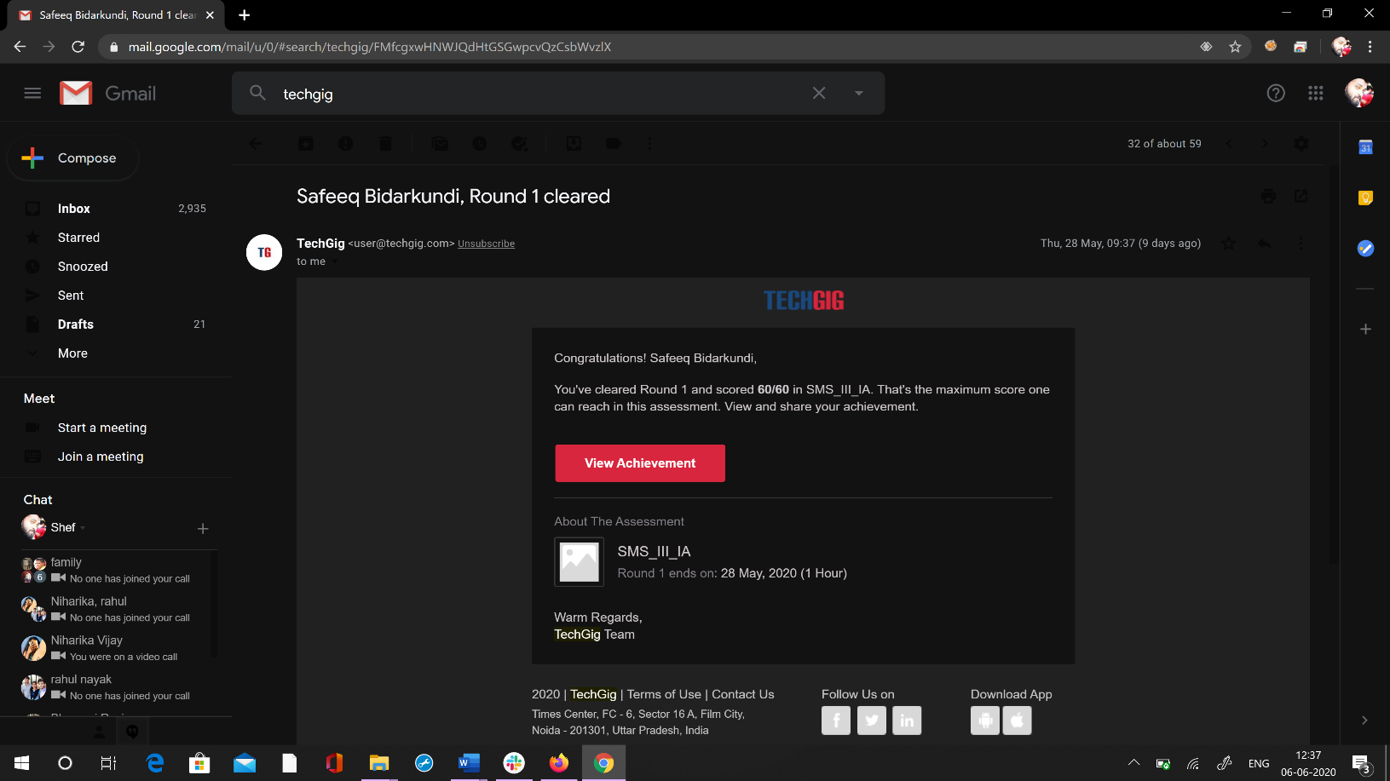

2)CertificationCourseDetails:

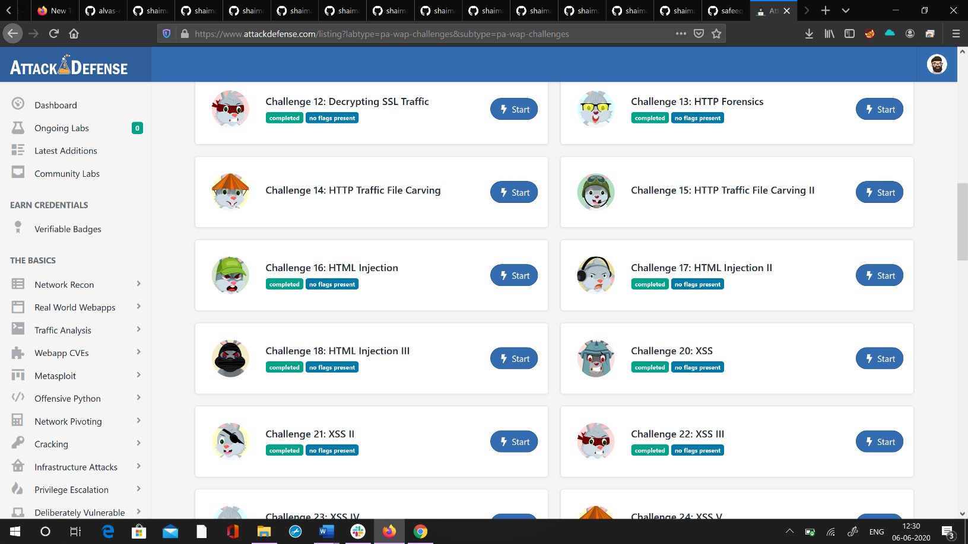

3)CodingChallenges:

Celsius=37.5

Fahreheit=(celsius*1.8)+32

Print(‘%0.IfdegreeCelsiusisequalto%0.IfdegreeFahrenheit’%(Celsius,Fahrenheit))